**DAILY ONLINE ACTIVITIES SUMMARY**

|  |  |  |  |  |  |  |  |  |
| --- | --- | --- | --- | --- | --- | --- | --- | --- |
| **Date:** | **27-06-2020** | | | | | **Name:** | **Rakesh M Kotian** | |
| **Sem & Sec** | **8 th sec-b** | | | | | **USN:** | **4al16cs072** | |
| **Online Test Summary** | | | | | | | | |
| **Subject** | | **-** | | | | | | |
| **Max. Marks** | | **-** | | **Score** | | |  | |
| **Certification Course Summary** | | | | | | | | |
| **Course** | **Python for machine learning** | | | | | | | |
| **Certificate Provider** | | | **Great learning** | | **Duration** | | | **6 hours** |
| **Coding Challenges** | | | | | | | | |
| **Problem Statement:**  Last remaining element | | | | | | | | |
| **Status:solved** | | | | | | | | |
| **Uploaded the report in Github** | | | | | **yes** | | | |
| **If yes Repository name** | | | | | **Rakeshkotian08** | | | |
| **Uploaded the report in slack** | | | | | **yes** | | | |

Online Test Details: (Attach the snapshot and briefly write the report for the same)

Certification Course Details: (Attach the snapshot and briefly write the report for the same)

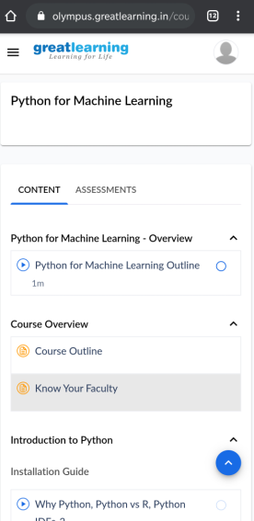

|  |  |  |
| --- | --- | --- |
| |  | | --- | | // C++ program to find the value of the  // reduced Array by reducing the array  // based on the given conditions    #include <iostream>  using namespace std;    // Function to find the value of the  // reduced Array by reducing the array  // based on the given conditions  int find_value(int a[], int n, int k)  {      // Variable to store the sum      int sum = 0;        // For loop to iterate through the      // given array and find the sum      for (int i = 0; i < n; i++) {          sum += a[i];      }        // Return the required value      return sum % k;  }    // Driver code  int main()  {      int n = 5, k = 3;      int a[] = { 12, 4, 13, 0, 5 };      cout << find_value(a, n, k);      return 0;  } |  |  | | --- | |  | |